**KYC ( Know Your Customer )**

KYC (Know Your Customer) is today a significant element in the fight against financial crime and money laundering, and customer identification is the most critical aspect as it is the first step to better perform in the other stages of the process.

In 2021, reported fraud losses rose to $5.8 billion, an increase of more than 70 percent in a single year. One way to combat the rise in financial fraud and money laundering is to reduce anonymous bank accounts and monitor suspicious activity.

In 2021, financial institutions spent an estimated $37.1 billion on AML-KYC compliance technology and operations.

KYC onboarding with facial recognition online is a hot topic in 2021.

In 2013 and 2014, $4.3 billion in fines were levied against financial institutions, which quadrupled the fines of the nine previous years combined. For example, JP Morgan was fined more than $2 billion for a failure to report suspicious activities. In 2021 alone, financial institutions were fined $2.7 billion.

In the U.S., Europe, the Middle East, and the Asia Pacific, a cumulated USD26 billion in fines have been levied for non-compliance with AML, KYC, and sanctions fines the past ten years (2008-2018) - let alone the reputational damage done and not measured.

According to the United Nations, criminals are laundering between $1.6 to $4 trillion annually (2 to 5% of global GDP). Stricter KYC/CDD processes are helping to stop that.

A 2022 report by the Federal Reserve showed that 95% of banks implemented stringent KYC procedures, reducing fraud cases by 30%.

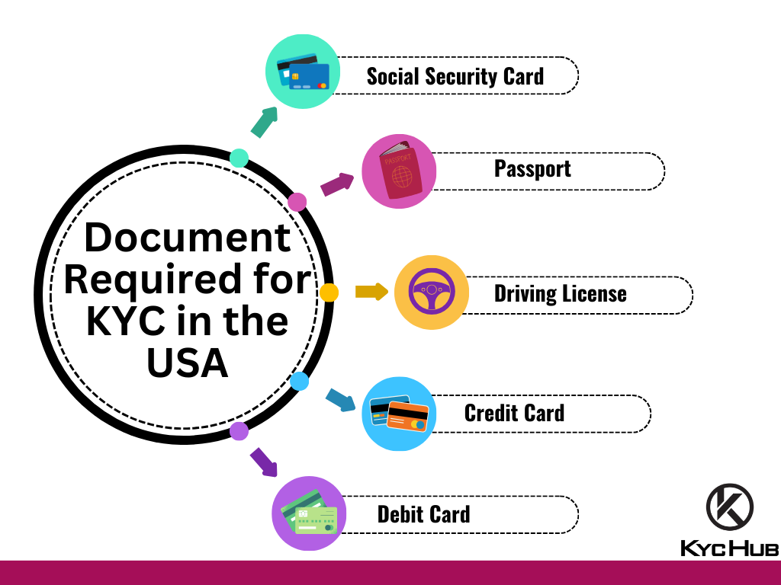

**AML (Anti – Money Laundering)**

AML regulations in the U.S. expanded after the Bank Secrecy Act (BSA) was passed in 1970. For the first time, financial institutions were required to report cash deposits of more than $10,000, collect identifiable information of financial account owners, and maintain records of transactions.

In 2021, financial institutions spent an estimated $37.1 billion on AML-KYC compliance technology and operations.

$60 million The penalty assessed against Bitcoin mixer Larry Dean Harmon for violating anti-money laundering laws.

Cryptocurrency has drawn increasing attention among AML professionals. Virtual coins provide anonymity to users, presenting criminals with a convenient way to store and move money.

According to cryptocurrency tracing firm Chainalysis, addresses connected to illicit activity sent nearly $23.8 billion worth of cryptocurrency in 2022, up 68% from 2021.

Some AML requirements apply to individuals. By law, U.S. residents must report receipts of multiple related payments totaling more than $10,000 to the Internal Revenue Service (IRS) on IRS Form 8300.

In 1989, multiple countries and organisations formed the global Financial Action Task Force (FATF). Its mission is to devise and promote international standards to prevent money laundering. Shortly after the 9/11 attacks on the US, FATF expanded its mandate to include AML and combatting terrorist financing.

Before turning to SAS, Landsbankinn had a screening system that flagged about 1,000 false positive transactions each day. With a limited number of investigators, lowering that number to focus on truly suspicious claims was important. Just months after turning to SAS Anti-Money Laundering, the number was down to about 100 daily – a 90% reduction in false positives.

AML and related fines increased by 52% in 2022, with the U.S. facing the highest AML penalties with enforcement actions of $3 billion, an increase of 151% from 2021.

Banks must monitor transactions, report suspicious activity, and verify customer identities. For example, a 2021 FinCEN report revealed that over 2 million Suspicious Activity Reports (SARs) were filed by banks, highlighting potential money laundering activities.

**CFPB (Consumer Financial Protection Bureau)**

The Consumer Financial Protection Bureau (CFPB) has proposed its long-awaited open banking rule in the hopes of improving competition in the US banking and payments sector.

6 months, for depository institutions that hold at least $500 billion in assets or for nondepository institutions that generated at least $10 billion in revenues in the prior calendar year, or are projected to generate $10 billion in the current calendar year;

1 year, for depository institutions that hold between $50 billion and $500 billion in assets and for all other nondepository institutions;

2.5 years, for depository institutions that hold between $850 million and $50 billion in assets; and

4 years, for depository institutions that hold less than $850 million in assets.

2022 report showing a 20% rise in credit reporting complaints. The CFPB target issues and enforce regulations, ensuring a safer and more transparent financial market for consumers.

